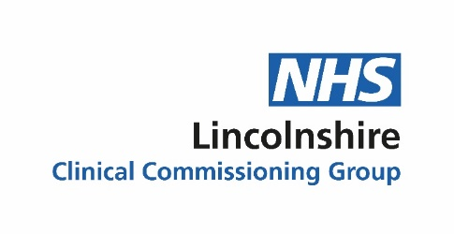

NHS Lincolnshire Clinical Commissioning Group is aware that some Lincolnshire GP practices, including this one, are experiencing significant issues with askmyGP, the online triage and consultation system. We would like to apologise to patients for any inconvenience this has caused.
The same issues are affecting practices nationally, and not caused by or the responsibility of Lincolnshire Clinical Commissioning Group or the individual practices, but are system issues with askmyGP. We are working urgently with NHS England, who are investigating with askmyGP, to resolve this as quickly as possible.
We would also like to add our apologies to patients who have experienced problems accessing our service. We are working had to rectify the problems and restore a 100% service for the patients of this practice
Harry Longman CEO askmyGP

